Standard Operating Procedure for **Colorimetric determination of Ammonium in soil extracts or soil pore water – 96 well plate method**

**Chemical Name or Process:**

**Colorimetric determination of ammonium in soil extracts or soil pore water**

**Purpose:** The method intends to determine the ammonium concentration in a soil pore water sample or a soil extract. The method is based on colorimetry, following the Berthelot reaction.

**Potential Hazards/Toxicity:**

* sodium nitroprusside
  + DANGER! Toxic if swallowed.
* Sodium salicylate
  + WARNING! Harmful if swallowed. Causes serious eye irritation.
* sodium hydroxide
  + DANGER! Causes severe skin burns and eye damage.
* household sodium hypochlorite (bleach)
  + DANGER! Causes severe skin burns and eye damage. Causes serious eye damage.

**Engineering Controls:**

**Personal Protective Equipment (PPE)-**

**Hand Protection:**

Nitrile gloves

**Eye Protection :**

Splash Goggles

Safety glasses or chemical splash goggles, as directed by advisor/P.I.. Goggles are required whenever there is a potential for a hazardous liquid splash, as per the Chemical Hygiene Plan Sec 3.1.b

**Skin and Body Protection:**

Lab personnel working with the chemicals need to wear full-length pants or its equivalent, closed-toe footwear with no skin being exposed, and a lab coat.

**Hygiene Measures:**

Wash hands after working with the hazardous substances and when leaving the lab/shop.

**First Aid Procedures for Chemical Exposures**

**In case of skin contact (bleach; sodium hydroxide):**

In case of contact, immediately flush skin with plenty of water for at least 15 minutes while removing contaminated clothing and shoes. Cold water may be used. Wash clothing before reuse. Thoroughly clean shoes before reuse. Get medical attention, as necessary.

**In case of eye contact (sodium salicylate; bleach; sodium hydroxide):**

Immediately flush eyes with plenty of water for at least 15 minutes. Check for and remove any contact lenses. Get medical attention.

**If swallowed:**

* Sodium nitroprusside
  + Immediately call a POISON CENTER or doctor/physician. If swallowed, rinse mouth
* Sodium salicylate
  + Call a POISON CENTER or doctor/physician if you feel unwell; Rinse mouth

**Special Handling and Storage Requirements**

* Sodium salicylate
  + Protect from light
* Sodium hypochlorite
  + Air Sensitive. Sensitive to light. Store in light-resistant containers

**Spill and Accident Procedure**

**Chemical Spill Dial 911 and 756-6661**

**Spill** – Assess the extent of danger. Help contaminated or injured persons. Evacuate the spill area. Avoid breathing vapors. If safe, confine the spill to a small area using a spill kit or absorbent material. Keep others from entering contaminated area (e.g., use caution tape, barriers, etc.).

**Small (<1 L)** – If you have training, you may assist in the clean-up effort. Use appropriate personal protective equipment and clean-up material. Double bag spill waste in plastic bags, label and arrange hazardous waste pick-up.

**Large (>1 L)** – Evacuate spill area. Dial **911** and EH&S at 756-6661 for assistance.Remain available in a safe, nearby location for emergency personnel.

**Chemical Spill on Body or Clothes** – Remove clothing and rinse body thoroughly in emergency shower for at least 15 minutes. Seek medical attention. *Notify supervisor, advisor or P.I. immediately.*

**Chemical Splash Into Eyes** – Immediately rinse eyeball and inner surface of eyelid with water from the emergency eyewash station for a minimum of 15 minutes by forcibly holding the eye open. Seek medical attention. *Notify supervisor, advisor or P.I. immediately.*

# **Medical Emergency Dial 911 or 756-6661**

**Life Threatening Emergency, After Hours, Weekends And Holidays** – Dial 911

*Note: All serious injuries must be reported to Supervisor/PI within 8 hours. Note: Any and all loss of consciousness requires a 911 call*

**Non-Life Threatening Emergency** –

* Students: Seek medical attention at the campus Health Center **M, T, Thu, Fr 8:00 am – 4:30 pm and W 9:00 am – 4:30 pm**
* Emergency Medical services in the community are available at any time at hospital emergency rooms and some emergency care facilities.

***All injuries must be reported to PI/Supervisor immediately and follow campus injury reporting. Follow procedures for reporting of student, visitor injury on the EH&S website at:*** <http://afd.calpoly.edu/riskmgmt/incidentreporting.asp>

* Paid staff, students, faculty: seek initial medical attention for all non-life threatening injuries at:
  + MED STOP, 283 Madonna Road, Suite B (next to See's Candy in Madonna Plaza)  
    (805) 549-8880 Hours: M-F 8a - 8p; Sat/Sun 8a - 4p
  + **After MED Stop Hours:** Sierra Vista Hospital Emergency Room   
    1010 Murray Avenue (805) 546-7651, Open 24 hours

***All injuries must be reported to PI/Supervisor immediately and follow campus injury reporting for employee injuries (Workmen’s Comp.). Follow procedures on the EH&S website at:*** [***http://afd.calpoly.edu/riskmgmt/incidentreporting.asp***](http://afd.calpoly.edu/riskmgmt/incidentreporting.asp)

**Decontamination/Waste Disposal Procedure**

Click here to enter text if different than outlined below

**General hazardous waste disposal guidelines:**

**Label Waste**

* A large hazardous waste container can be found on the windowside bench in 180-241. It has a hazardous waste tag denoting all ingredients. All intermediate waste containers for waste generated during the procedure must be labeled similarly as soon as the first drop of waste is added to the container. Generic waste labels can be found here: <http://afd.calpoly.edu/ehs/docs/hazwaste_label_template.pdf>

**Store Waste**

* Store hazardous waste in closed containers, in secondary containment and in a designated location
* Double-bag dry waste
* Waste must be under the control of the person generating & disposing of it
* If the waste jar becomes full or close to full, make sure Craig Stubler knows and he will replace it. Waste containers cannot be more than 75% full to allow for liquid expansion.

**Dispose of Waste**

* Dispose of regularly generated chemical waste as per guidelines on EH&S website at: <http://afd.calpoly.edu/ehs/docs/csb_no6.pdf>
* Prepare for transport for pick-up. Use secondary containment.

Call EH&S at 756-6661 for questions.

**Empty Containers-**

* Dispose as hazardous waste if container once held extremely hazardous waste (irrespective of the container size) A list can be found at: <http://afd.calpoly.edu/ehs/docs/extremely_hazardous_wastes.pdf>
* All other containers are legally empty once a concerted effort is made to remove, pour out, scrape out, or otherwise completely empty the vessel. These may be disposed of as recycling or common trash as appropriate.

**Safety Data Sheet (SDS) Location**

Online SDS can be accessed at: <http://siri.org/msds/index.php>

or MSDSOnline at: <http://hq.msdsonline.com/csuedusl/Search/Default.aspx>

**Protocol/Procedure**

**PREMISE OF METHOD:**

In the inodphenol-blue or Berthelot method, Ammonium reacts with the hypochlorite to form monochloramine (NH2Cl).

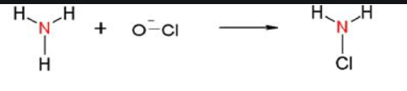

The monochloramine then reacts with salicylate to form benzoquinone monoamine.

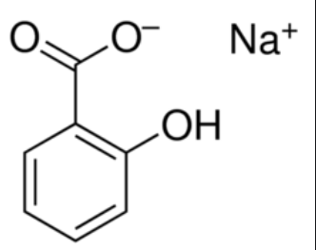 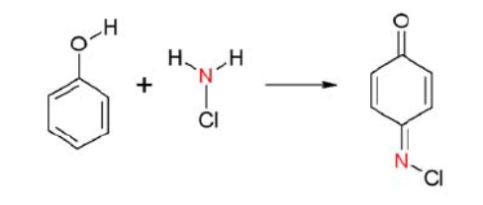 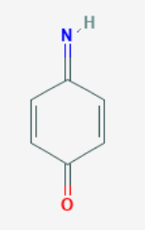

The benzoquinone monoamine couples with salicylate to give the colored indophenol dye.

+ à 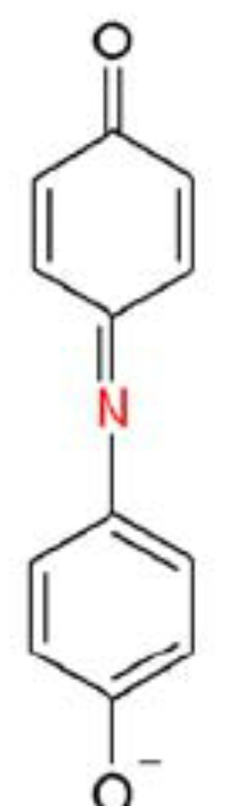

The intensity of the color represents the concentration of ammonium in the sample, which is determined in a platereader at λ = 650 nm.

1. **Prepare reagent**

Chemicals:

* Sodium nitroprusside (sodium nitroferricyanide)
* Sodium salicylate
* Sodium citrate
* Sodium tartrate
* Sodium hydroxide
* Sodium hypochloride (bleach)

Procedure

2 reagents are prepared, referred to as reagent A and reagent B. Once prepared, reagents can be stored in the refrigerator for several months.

***Reagent A:***

* Weigh out
  + 0.05g sodium nitroprusside
  + 13g sodium salicylate
  + 10g sodium citrate
  + 10g sodium tartrate
* Mix chemicals in 100 mL DI water
* Label on bottle and on foil wrapper:
  + Sistla Lab, NH4 reagent A
  + Prepared by: YOUR NAME(if Craig, note that)
  + Date: Month/day/year (20XX)
* Wrap bottle in aluminum foil to protect from light, put additional label on foil
  + Sistla Lab, NH4 reagent A
  + Prepared by: YOUR NAME(if Craig, note that)
  + Date: Month/day/year (20XX)

***Reagent B:***

* Dissolve 6g sodium hydroxide in 100 mL DI water and add 2 mL sodium hypochloride
  + Sistla Lab, NH4 reagent B
  + Prepared by: YOUR NAME(if Craig, note that)
  + Date: Month/day/year (20XX)

1. **Prepare standards**

Materials:1000 ppm NH4+ standard solution

* Buffer used for soil extraction
* One new or acid-washed falcon tube
* Deep-well 96-well plate
* 5ml, 1ml and 200ul pipets and pipet tips
* Bucket for used 5ml and 1ml pipette tips
* Trashcan for used 200ul tips
* Printed plate plan sheet(s), cut out and labeled, attached to notebook appropriately

Procedure

Make your standards in the range expected for your project. Use the same solution to prepare you standards as used in your samples, namely:

* For soil pore water samples, use DI water for blank and to dilute standards
* **For 2 M KCl soil extracts, use 2M KCl for blank and to dilute standards (typical in our lab)**
* For 0.2 M KCl soil extracts, use 0.2 M KCl for blank and to dilute standards
* For 0.5 M K2SO4 soil extracts, use 0.5M K2SO4 for blank and to dilute standards

This solution will further be referred to as the matrix. Once you have determined your matrix:

1. Prepare a 10ppm stock by placing 0.500g 1000 ppm NH4+ standard in 49.500g of the matrix. Mix well. (if changing volumes, follow M1*V1=M2*V2)
2. Prepare dilutions of the 10ppm stock in Eppendorf tubes as follows and as shown below (use a 1000ul (blue) pipette for volumes >100ul and a 100ul (yellow) pipette for the 10-100ul volumes)

|  |  |  |  |  |  |  |  |  |
| --- | --- | --- | --- | --- | --- | --- | --- | --- |
| Plate position | 1 A | 1 B | 1 C | 1 D | 1 E | 1 F | 1 G | 1 H |
| **ppm NH4+** | **5** | **2.5** | **1** | **0.75** | **0.5** | **0.25** | **0.1** | **0** |
| volume of 10ppm to pipette (uL) | 500 | 250 | 100 | 75 | 50 | 25 | 10 | 0 |
| Volume of matrix to pipette (uL) | 500 | 750 | 900 | 925 | 950 | 975 | 990 | 1000 |

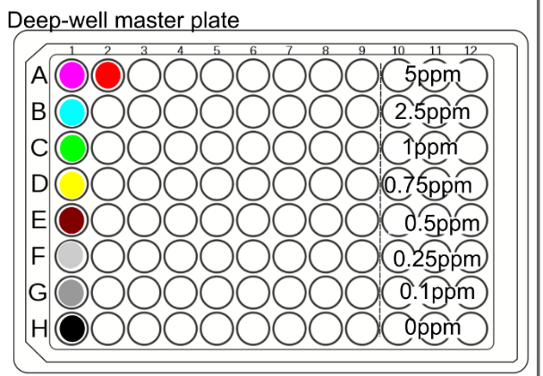

Figure 1. Master deep-well plate. Standards are in column 1. Sample A1-3 (assay plate) is in A2 in deep-well plate.

1. **Process samples**

***Because you are working with such a low sample volume, it is important that you work quickly and efficiently when pipetting to reduce error associated with evaporation. Use lids for 96well plates when you are incubating trays or whenever you are not actively working on a plate***

Materials:

* Standards
* Samples
* NH4+ reagent A and B
* Acid-washed 300ul volume clear 96-well plate, labeled with name/PI/plateID
* Acid-washed deep-well 96-well plate filled with standards, from above
* 100ul Multichannel pipette
* 200ul pipette tips
* 1 mL pipette
* 1ml pipette tips
* 96-well template (at end of protocol)
* 2 acid washed pipetting troughs
* Dry waste container for tips in contact with reagent

Procedure

* Fill out your **96-well template plate plan**. Record this in your lab notebook and your meta-data file. **It must match the ‘biogeochem_example.xlsx’ NH4_plate_plan file**. (**Negative control in H7-9, standards in A-H 10-12**). If you have more than 23 samples, use additional plates.  If you have less, still place your negatives and standards in the same places on the plate to avoid errors.
* For the assay plate (figure 2), use three adjacent columns of the same row for replicates of the same sample, making sure to leave the last three columns for the standards.
  + Ex. sample 1 (magenta) would be marked in wells A1, A2, A3, and sample 2 (cyan) would go in wells B1, B2, and B3.
  + Keep samples in order, make sure they exactly match the Sistla Lab **biogeochem_example.xlsx’** template and is recorded in your lab notebook and meta-data file. *You should double check you also have the fresh weight of the soil samples that were extracted and the gravimetric moisture complete and recorded in the file*.
* This should correspond to a version of the deepwell master plate plan (i.e., sample A 1 – 3 would be pipetted in A 2 in the deep well plate). You only need to pipette columns in the deep well plate for every three columns in the assay plate. Pipette samples one by one into columns 2, 5, 8 (all rows). Example: Sample1: A2, sample 2 B2, sample 3 C2, etc.  **Make a plate map of your master plate in your notebook and record each sample position**.

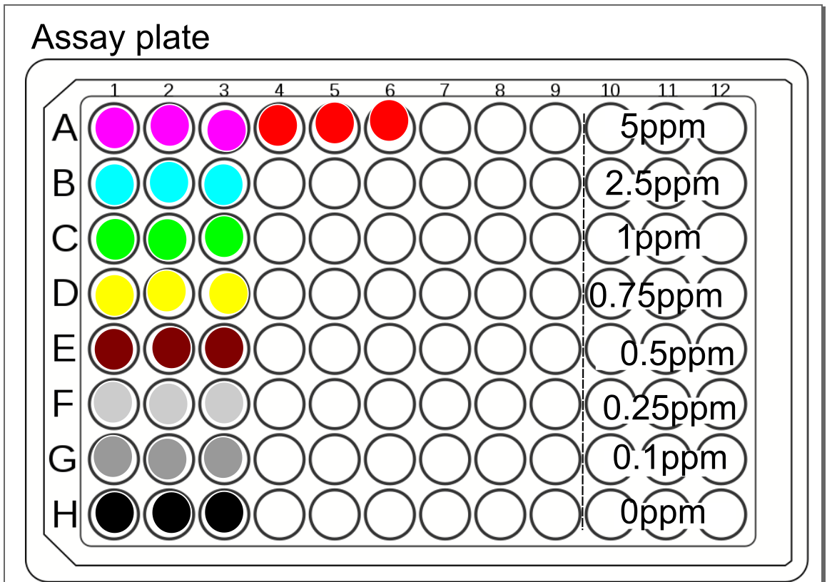

* Using the 5 mL pipette, fill the appropriate well of the **deep**/master plate with 1.8mls (if not freezing the plate afterwards) or 1.5mls (if freezing the plate) of the corresponding sample.
  + You want to also put the standards in the master plate because you want to pipette them identically to the samples with the multichannel.
  + You can use a piece of cardboard / plate lid to cover filled columns so you can keep track of where you have pipetted.
  + **Change tips between samples**, and keep the big tips for washing later
* Transfer 100ul of sample from the deepwell master plate to the appropriate wells in the shallow plate. Use a written plate map!
  + You can use the same tips for each replicate column, change tips between samples
  + Make sure that the pipette tips are all well-attached, that you go all the way to the bottom of the wells, and that the same amount of bubble-free liquid is collected
  + Also make sure to keep pipette vertical so you don’t end up with lots of droplets of sample stuck to the outside of the tips.
  + Use cardboard/ plate lid to cover the wells you have filled, both to keep track of where you are, and to keep sleeve/arm/body/soil gunk out of the wells.
* Label two pipetting troughs – one with NH4 reagent A, and the other with NH4 reagent B.
  + Pour ~5mls of the appropriate reagent into its trough and cover with a small piece of foil
* Using the 100ul multichannel pipette, allocate **31 uL** **reagent A to each well**. You can reuse the tips for each column
* Using the 100ul multichannel pipette, allocate **31 uL reagent B to each well**. You can reuse the tips for each column
* Cover the plate with foil and carefully tap its edges a few times to mix the reagent and sample.
* After 1 hour (and up to 4 hours), read absorbance in the platereader at 650 nm (see below)

1. **Determine concentration on the Tecan (rm 180-252)**

* Log on to the platereader computer.
* Turn on the platereader by pressing the power switch on the back, just above the power cable.
* If this is your first time running the platereader on this computer or first time in a while, open excel and just check that it is linked to your account and activated (it will ask you to sign in if not).
* Open the tecan-I-control software
* Click on the infinite 2000Pro at the top and then connect
* Close the protocol pop-up
* Go to file --> open --> Ammonium
* Check the settings (plate = “[GRE96ft] – Greiner 96 Flat Transparent”; “plate with cover” checked; all wells yellow in the plate, Absorbance: 650nm, 25 flashes, 0 settle time)
* Open the platereader drawer using the button on the top
* Insert plate with lid and with plate oriented so letters appear on the left and numbers on the top
* Press door button on top of platereader to close the drawer
* Press start button in the software and the plate will start reading
* The software starts writing the data into an excel file. Make sure to rename the tab as the plate ID, and click off the tab name to somewhere into the excel spreadsheet after renaming before starting the next plate (otherwise the program will open a completely new excel file if you read another plate)
* Once the plate has finished, the drawer will open. Put the lid back on the plate and replace the plate with a new one and repeat the read cycle.
* When finished, save the file in the form of [date]_[project]_ammonium_[name initials].xlsx (replace the “[]’ and their contents though!)
* Upload file to Sistla Lab OneDrive appropriate study folder. **Check that standard curve is appropriate in excel (R2 >>0.98, reasonable slope, intercept), negative control absorbance is comparable to 0 NH4+ standard. Record that you have confirmed these details in your lab notebook and that the remaining extract, reagents are frozen. Note where they are stored.**
* Close the Tecan I control software. **If it asks you if you want to save changes to the protocol file, say no, but also check what changed** (because this could mean you accidentally changed the read conditions prior to reading your plate).
  + - * + It is important that you close the platereader software and let the computer disconnect/stop talking to the platereader. Otherwise others will not be able to connect to it.
* Turn off the plate reader and log out of the computer.

1. **Clean-up**

Dispose all liquid in plates in the designated waste container (ie flick into the beaker and then pour the contents of the beaker in the sealed hazardous waste container). Rinse 1x with deionized water and dispose the first rinse in waste container. Subsequently, rinse the plates three times over the sink with deionized water, and place in the acid bath. Make sure the wells of the plate are actually filled with the acid solution, as air bubbles have a tendency to form. Repeat the rinsing and acid bathing for the 1 and 5ml tips.

When drying tips after rinsing following the acid bath, place them back in the tip box with the lid ajar. Both the tips and plates can be placed in a 50C oven, but don’t let them touch the edges of the oven or completely cover a layer/block airflow, because they will warp/melt!

1. **Calculations**

The linear regression equation is required for calculating NH4+­­ concentration (ppm) in soil extract.

$$\left[{NH}_{4}^{+}\right] (ppm)=\frac{Abs-intercept}{slope}$$

Dry soil weight is calculated using soil moisture and fresh weight.

Or

NH4+ concentration (ug/g soil) in soil subsample is determined as following:

$$\left[{NH}_{4}^{+}\right] ({μg}/{g soil)=\frac{\left[{NH}_{4}^{+}\right] in ppm ×extract volume in mL}{dry soil weight in g}}$$

Extract volume can be 25 or 50 mL.

**NOTE:**

Any deviation from this SOP requires approval from PI.

**Date:** Click here to enter a date. **P.I. or Supervisor:** Dr. Seeta Sistla

**Documentation of Training** (signature of all users is required)

* The Principal Investigator must ensure that his/her laboratory personnel have attended appropriate laboratory safety training or refresher training within the last one year.
* Training must be administered by PI or Lab Manager to all personnel in lab prior to start

of work with particularly hazardous substance or newly synthetic chemical listed in the

SOP.

* Refresher training will need to be provided when there is a change to the work

procedure, an accident occurs, or repeat non-compliance.

I have read and understand the content, requirements, and responsibilities of this SOP:

|  |  |  |
| --- | --- | --- |
| **Name** | **Signature** | **Date** |
| Click here to enter text. |  | Click here to enter a date. |
| Click here to enter text. |  | Click here to enter a date. |
| Click here to enter text. |  | Click here to enter a date. |
| Click here to enter text. |  | Click here to enter a date. |
| Click here to enter text. |  | Click here to enter a date. |
| Click here to enter text. |  | Click here to enter a date. |
| Click here to enter text. |  | Click here to enter a date. |
| Click here to enter text. |  | Click here to enter a date. |
| Click here to enter text. |  | Click here to enter a date. |
| Click here to enter text. |  | Click here to enter a date. |
| Click here to enter text. |  | Click here to enter a date. |
| Click here to enter text. |  | Click here to enter a date. |
| Click here to enter text. |  | Click here to enter a date. |
| Click here to enter text. |  | Click here to enter a date. |

**Appendix**

Empty 96-well plate plan:

